SIMATS ENGINEERING (SAVEETHA SCHOOL OF ENGINEERING)
Department of Computer Science and Engineering

ASSESSMENT TOOL 1 – Coding Challenge Task

Course Code: | CSA06 | Course Title: | Design and Analysis of Algorithms
CO Assessed: | CO4: Articulation (BL4, BL5) | Assessment: | Assessment Tool 1 – Coding Challenge Task
Weightage: | 40% of CIA | Total Marks: | 100
CO4 Statement: | Solve optimization problems using dynamic programming and greedy strategies.
Student Name: | G Durga Surya Prasad | Reg. No.: | 192425158
Section / Batch: | Slot-C | Date: | 20-08-2026

Instructions to Students
- Answer the following question. Total Marks: 100.
- Carefully analyze the given questions.
- Write clear code for the given problem.
- Analyze the Time complexity and Space complexity of your code using dynamic programming and greedy strategies

Question Type | Focus Area | Questions
Coding Challenge Task | Focus on Code and analyze optimization problems using dynamic programming and greedy strategies | Q1

SECTION A – Coding Challenge Task

Assigned: Q11. Longest Common Subsequence (LCS)
Two strings are given, and the task is to find the longest subsequence that appears in both strings in the same
relative order. The characters of the subsequence need not be contiguous, but the sequence order must be
preserved. The objective is to compute the maximum possible length of such a common subsequence. Use Dynamic
Programming to determine the optimal result efficiently.
Input Format:
s1 = first string
s2 = second string
Sample Input:
s1 = ABCDGH
s2 = AEDFHR
Expected Output:
LCS Length = 3

Longest Common Subsequence (LCS)
Aim
To implement the Longest Common Subsequence (LCS) problem using Dynamic Programming and determine the maximum length of a subsequence common to two given strings while preserving the relative order of characters.
Problem Statement
Two strings are given, and the task is to find the longest subsequence that appears in both strings in the same relative order. The characters of the subsequence need not be contiguous, but their order must be preserved.
For example, for:
- s1 = ABCDGH
- s2 = AEDFHR
The longest common subsequence is ADH.
Therefore:
LCS Length = 3
Given Input:
s1 = first string
s2 = second string
Sample Input:
s1 = ABCDGH
s2 = AEDFHR
Expected Output:
LCS Length = 3
Algorithm
- Start the program.
- Read the two strings s1 and s2.
- Let m be the length of s1 and n be the length of s2.
- Create a DP table dp[m+1][n+1] and initialize all values to 0.
- Traverse the characters of both strings using two nested loops.
- If s1[i-1] == s2[j-1], set:
- dp[i][j] = dp[i-1][j-1] + 1
- Otherwise, set:
- dp[i][j] = max(dp[i-1][j], dp[i][j-1]).
- After filling the table, dp[m][n] contains the length of the LCS.
- Trace back through the DP table to find the actual LCS.
- Display the LCS and its length.
- Stop the program.
Pseudocode
def lcs(s1, s2):
m = len(s1)
n = len(s2)

# Create DP table
dp = [[0] * (n + 1) for _ in range(m + 1)]

# Fill DP table
for i in range(1, m + 1):
for j in range(1, n + 1):
if s1[i - 1] == s2[j - 1]:
dp[i][j] = dp[i - 1][j - 1] + 1
else:
dp[i][j] = max(dp[i - 1][j], dp[i][j - 1])

# Find the LCS string
i = m
j = n
result = []

while i > 0 and j > 0:
if s1[i - 1] == s2[j - 1]:
result.append(s1[i - 1])
i -= 1
j -= 1
elif dp[i - 1][j] >= dp[i][j - 1]:
i -= 1
else:
j -= 1

result.reverse()

return dp[m][n], ''.join(result)

# Input
s1 = "ABCDGH"
s2 = "AEDFHR"

# Calculate LCS
length, sequence = lcs(s1, s2)

print("LCS =", sequence)
print("LCS Length =", length)

Code:
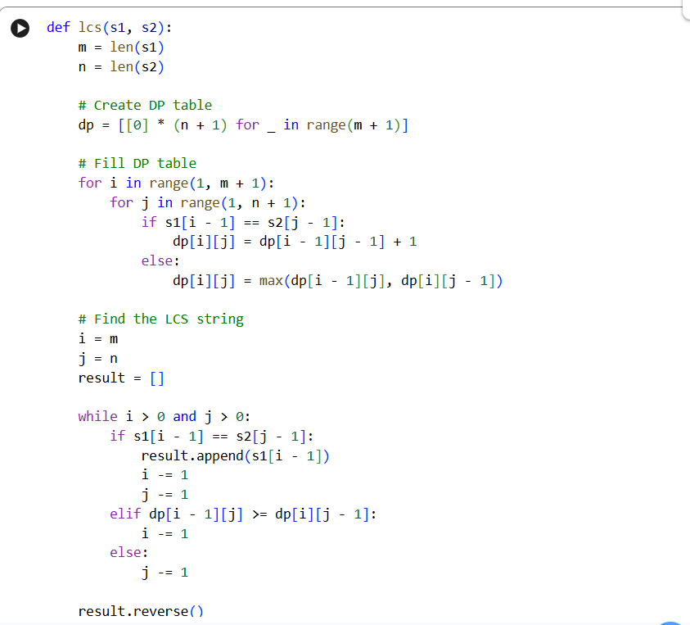
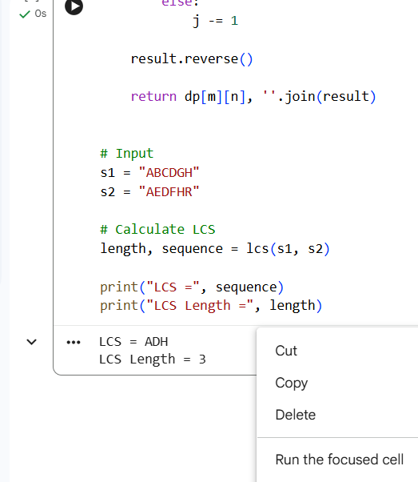
Dynamic Programming Formula
dp[c] = max(dp[c], dp[c - weight[i]] + value[i])
Here, dp[c] represents the maximum profit that can be obtained for capacity c. Since the items are reusable, the same item can be considered again when calculating dp[c - weight[i]].
Input
Enter number of items : 3
Enter item profits : 10 30 20
Enter item weights : 5 10 15
Enter maximum capacity : 100
Output
🎒 DYNAMIC KNAPSACK OPTIMIZER

Let dp[i][j] represent the length of the Longest Common Subsequence of the first i characters of s1 and the first j characters of s2.
If s1[i-1] == s2[j-1]:

dp[i][j] = dp[i-1][j-1] + 1

Otherwise:

dp[i][j] = max(dp[i-1][j], dp[i][j-1])
Initial condition:
dp[0][j] = 0
dp[i][0] = 0
The final value is:
dp[6][6] = 3
Final Result
LCS = ADH
LCS Length = 3
Result
The Longest Common Subsequence problem was successfully implemented using Dynamic Programming. For the given strings ABCDGH and AEDFHR, the longest common subsequence obtained is ADH, with a length of 3.
Conclusion
The Dynamic Programming approach efficiently solves the LCS problem by storing the solutions to smaller subproblems in a DP table. This avoids repeated calculations and provides the optimal result. For the given input, the LCS is ADH and the maximum LCS length is 3.

Code of Conduct
I G Durga Surya Prasad(192425158) (Name / Reg No) certify that this submission is my original work and that I have adhered to the guidelines specified for this assessment. I understand that any violation of academic integrity rules will result in disciplinary action.
Signature of the Student: _G Durga Surya Prasad____

RUBRICS FOR CALCULATION

Coding Challenge Task

Criteria | Weightage | Level 4 (Exemplary) | Level 3 (Proficient) | Level 2 (Developing) | Level 1 (Beginning)
Problem Understanding | 20% | Clearly understands problem constraints, edge cases, and competitive requirements | Understands  problem with  minor gaps in constraints | Partial understanding; misses key constraints | Misinterprets problem or constraints
Algorithm | 25% | Selects optimal algorithm with best time and space complexity for  competitive constraints | Uses efficient algorithm with  minor scope for improvement | Uses basic/inefficient approach | No clear algorithmic approach
Code Implementation | 20% | Writes correct, efficient, and clean  code that passes all constraints | Code works with minor errors or inefficiencies | Partially correct code; fails for some  cases | Code does not execute or gives incorrect results
Competitive Performance | 20% | Solves problem within time limits and  handles large inputs effectively | Solves within acceptable time with minor delays | Struggles with time limits or larger inputs | Unable to solve within time constraints
Test Case Handling | 15% | Handles all test cases including edge and hidden cases | Handles most test cases | Misses important edge cases | Fails on multiple test cases

Marks Evaluation:
Criteria | Wt. | Level 4 –  Exemplary | Level 3 –  Proficient | Level 2 –  Developing | Level 1 –  Beginning
Problem Understanding | 20%
Algorithm | 25%
Code Implementation | 20%
Competitive Performance | 20%
Test Case Handling | 15%
Total Marks (100):

Faculty In-charge | Course Coordinator | Head of Department
Name: | Name: | Name:
Signature: _______________ | Signature: _______________ | Signature: _______________
Date: ___________________ | Date: ___________________ | Date: ___________________

